**CST 2355 Group Assignment 2**

**Website: VisualBudget**

Group Members:

* **Jessy Seo** — seo00029@algonquinlive.com
* **Yuanyuan Xi** — xi000016@algonquinlive.com
* **Kang Tian** — tian0063@algonquinlive.com

**1. Introduction**

**Description:**

VisualBudget is a web application that allows users to monitor and visualize their income and spending by category.

Users can create an account to enter their income and spending data manually.

The application automatically generates dashboards that display their financial situation using pie charts and bar charts, broken down by category for both income and spending.

**Purpose:**

* Help users gain clear insights into their financial habits.
* Encourage budgeting, investment tracking, and long-term financial planning.

**Technical Implementation (Proposed):**

* **Frontend:** HTML, CSS, JavaScript
* **Backend:** PHP with a mysql database
* **Hosting:** Local testing with XAMPP
* **Data Visualization:** Chart.js

**2. Page Overview**

**(1) Index Page**

* Provides an introduction to VisualBudget.
* A **“Get Started”** button allows the user to begin using the application.
* A **“Contact Us”** link is available at the bottom of each page to view contact information.

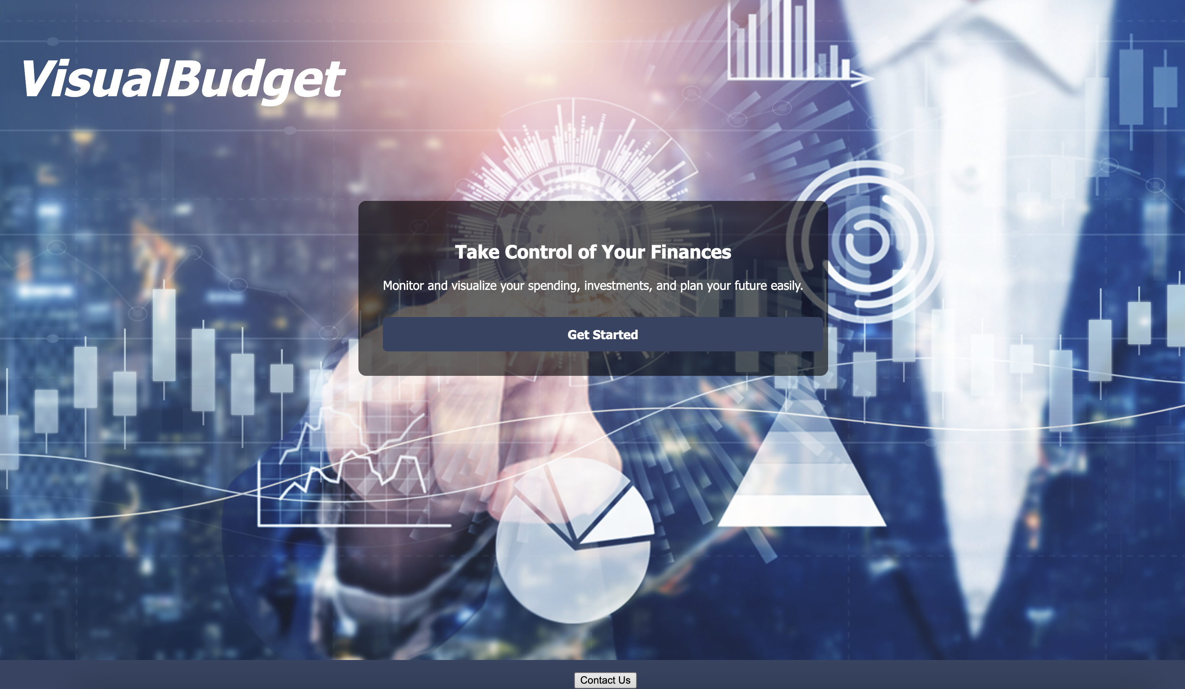



**(2) Login Page**

* Users can log in by entering their email and password.
* If they don’t have an account, they can navigate to the **Sign-Up** page.

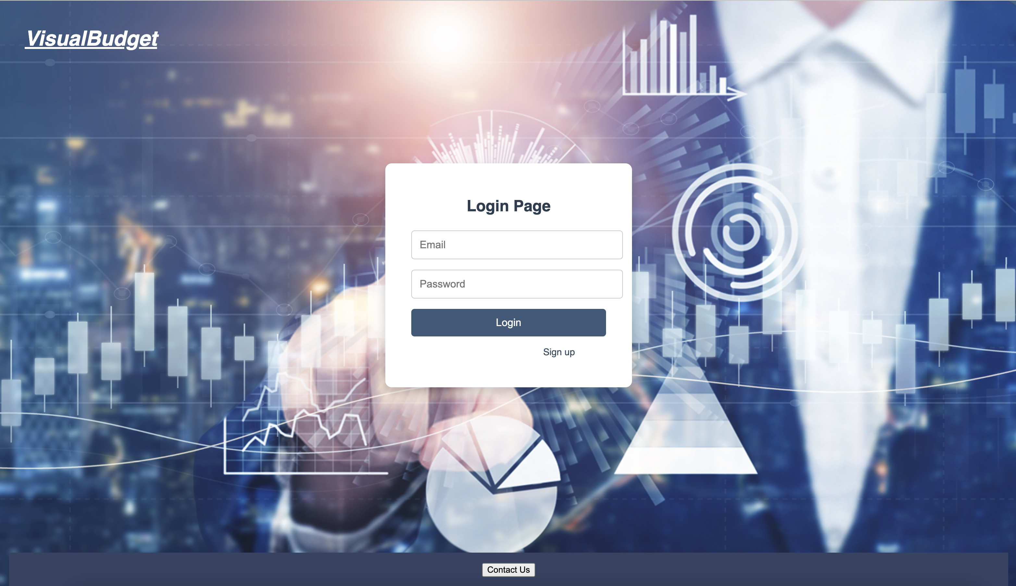

**(3) Sign-Up Page**

* New users can create an account by entering their personal information.

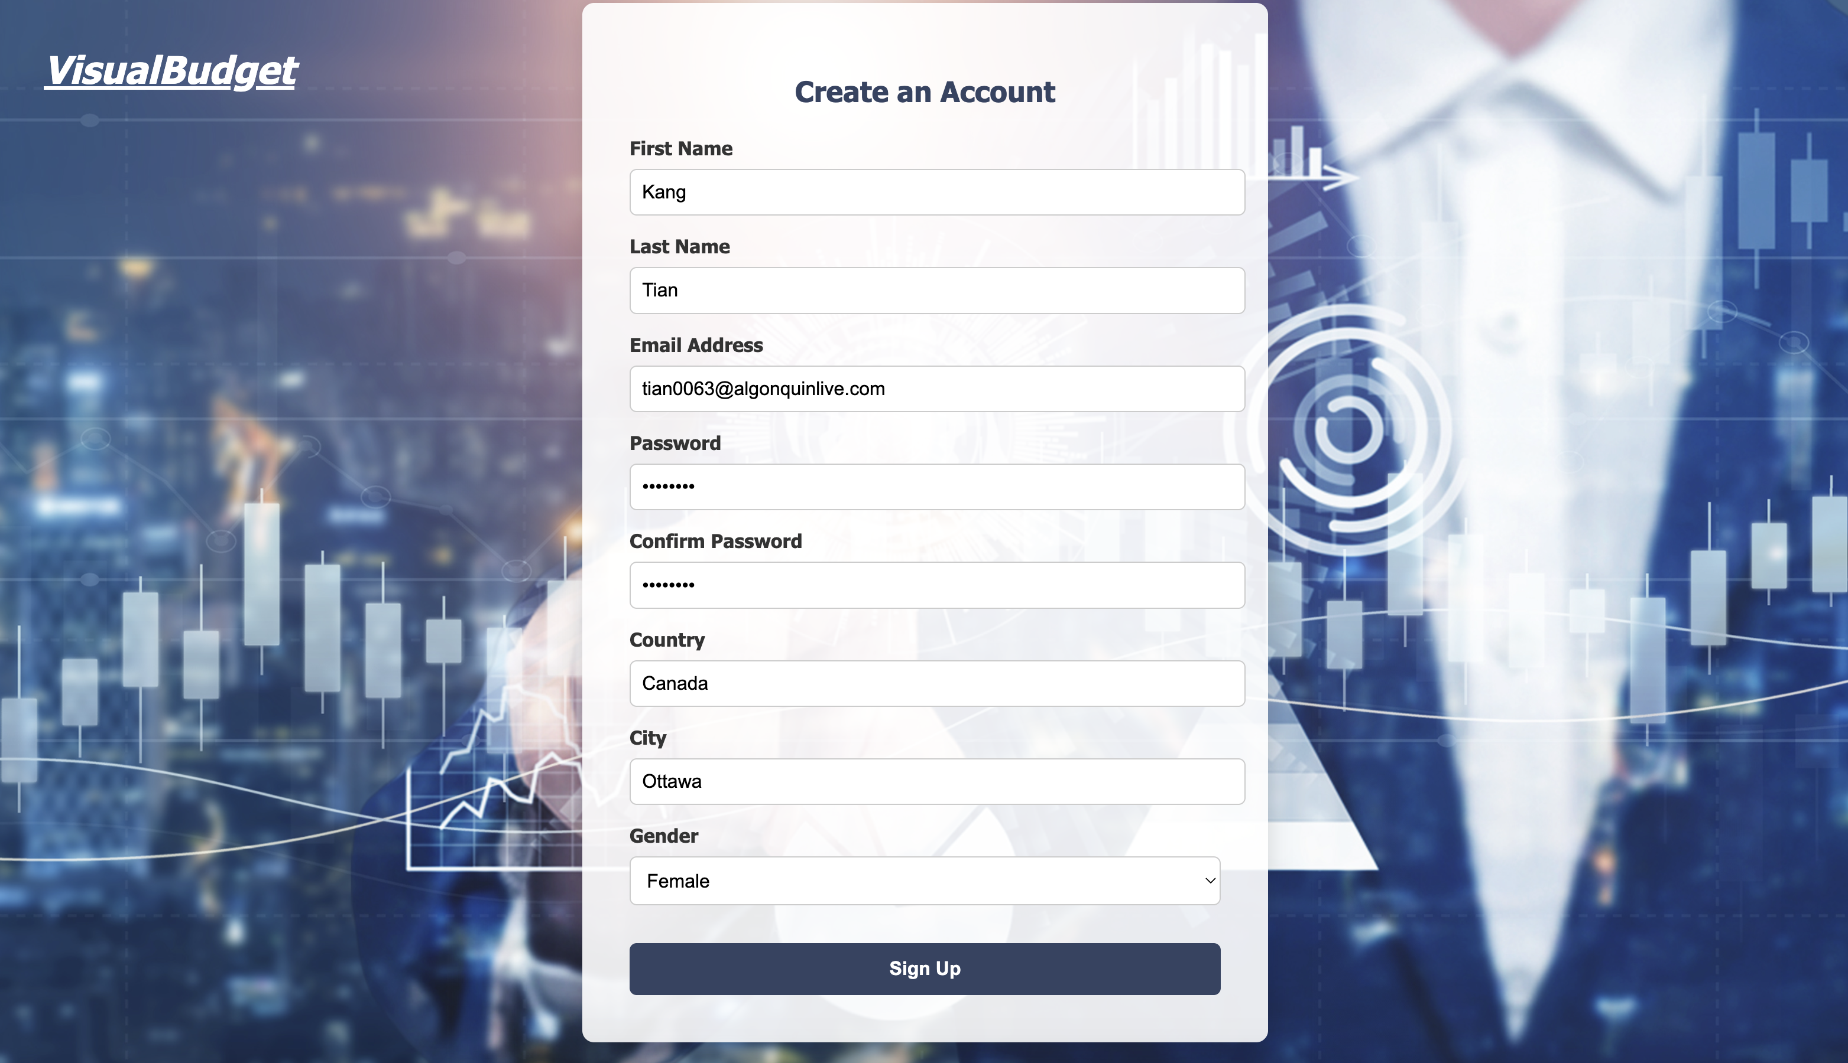

* After registration, users can log in using their email and password.

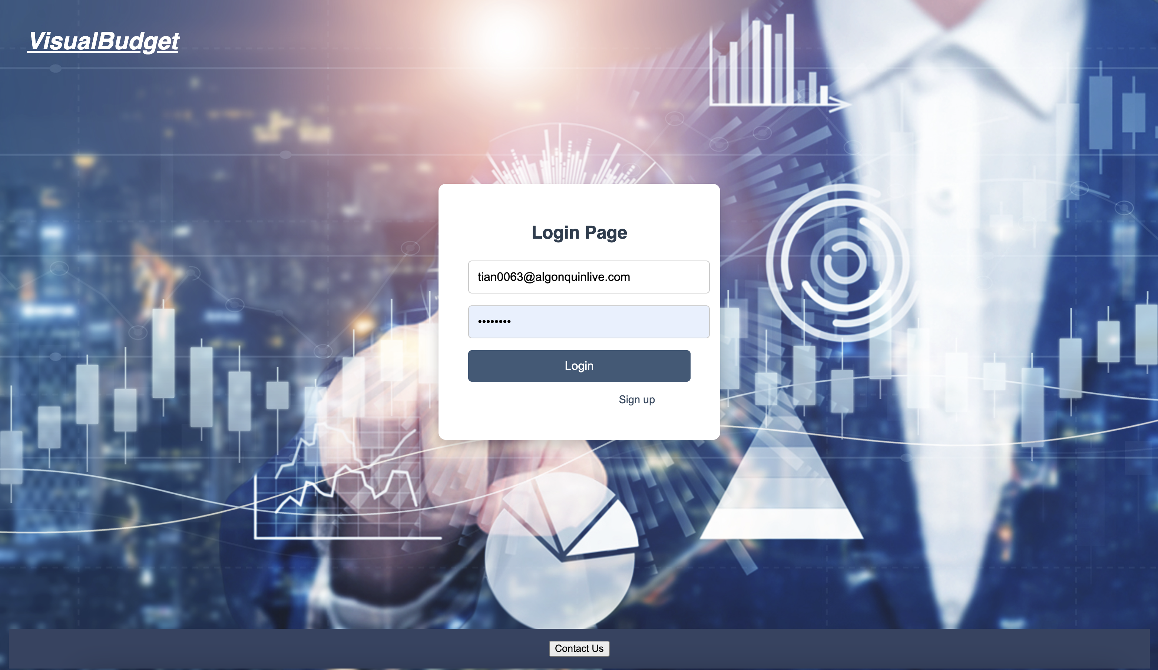

**(4) Data Input Page**

* Users can enter their financial data by clicking **“Add Income”** or **“Add Spending”**.
* Users can change the date for the entry.
* Data fields include:
  + **Category** (required)
  + **Amount** (required)
  + **Note** (optional)

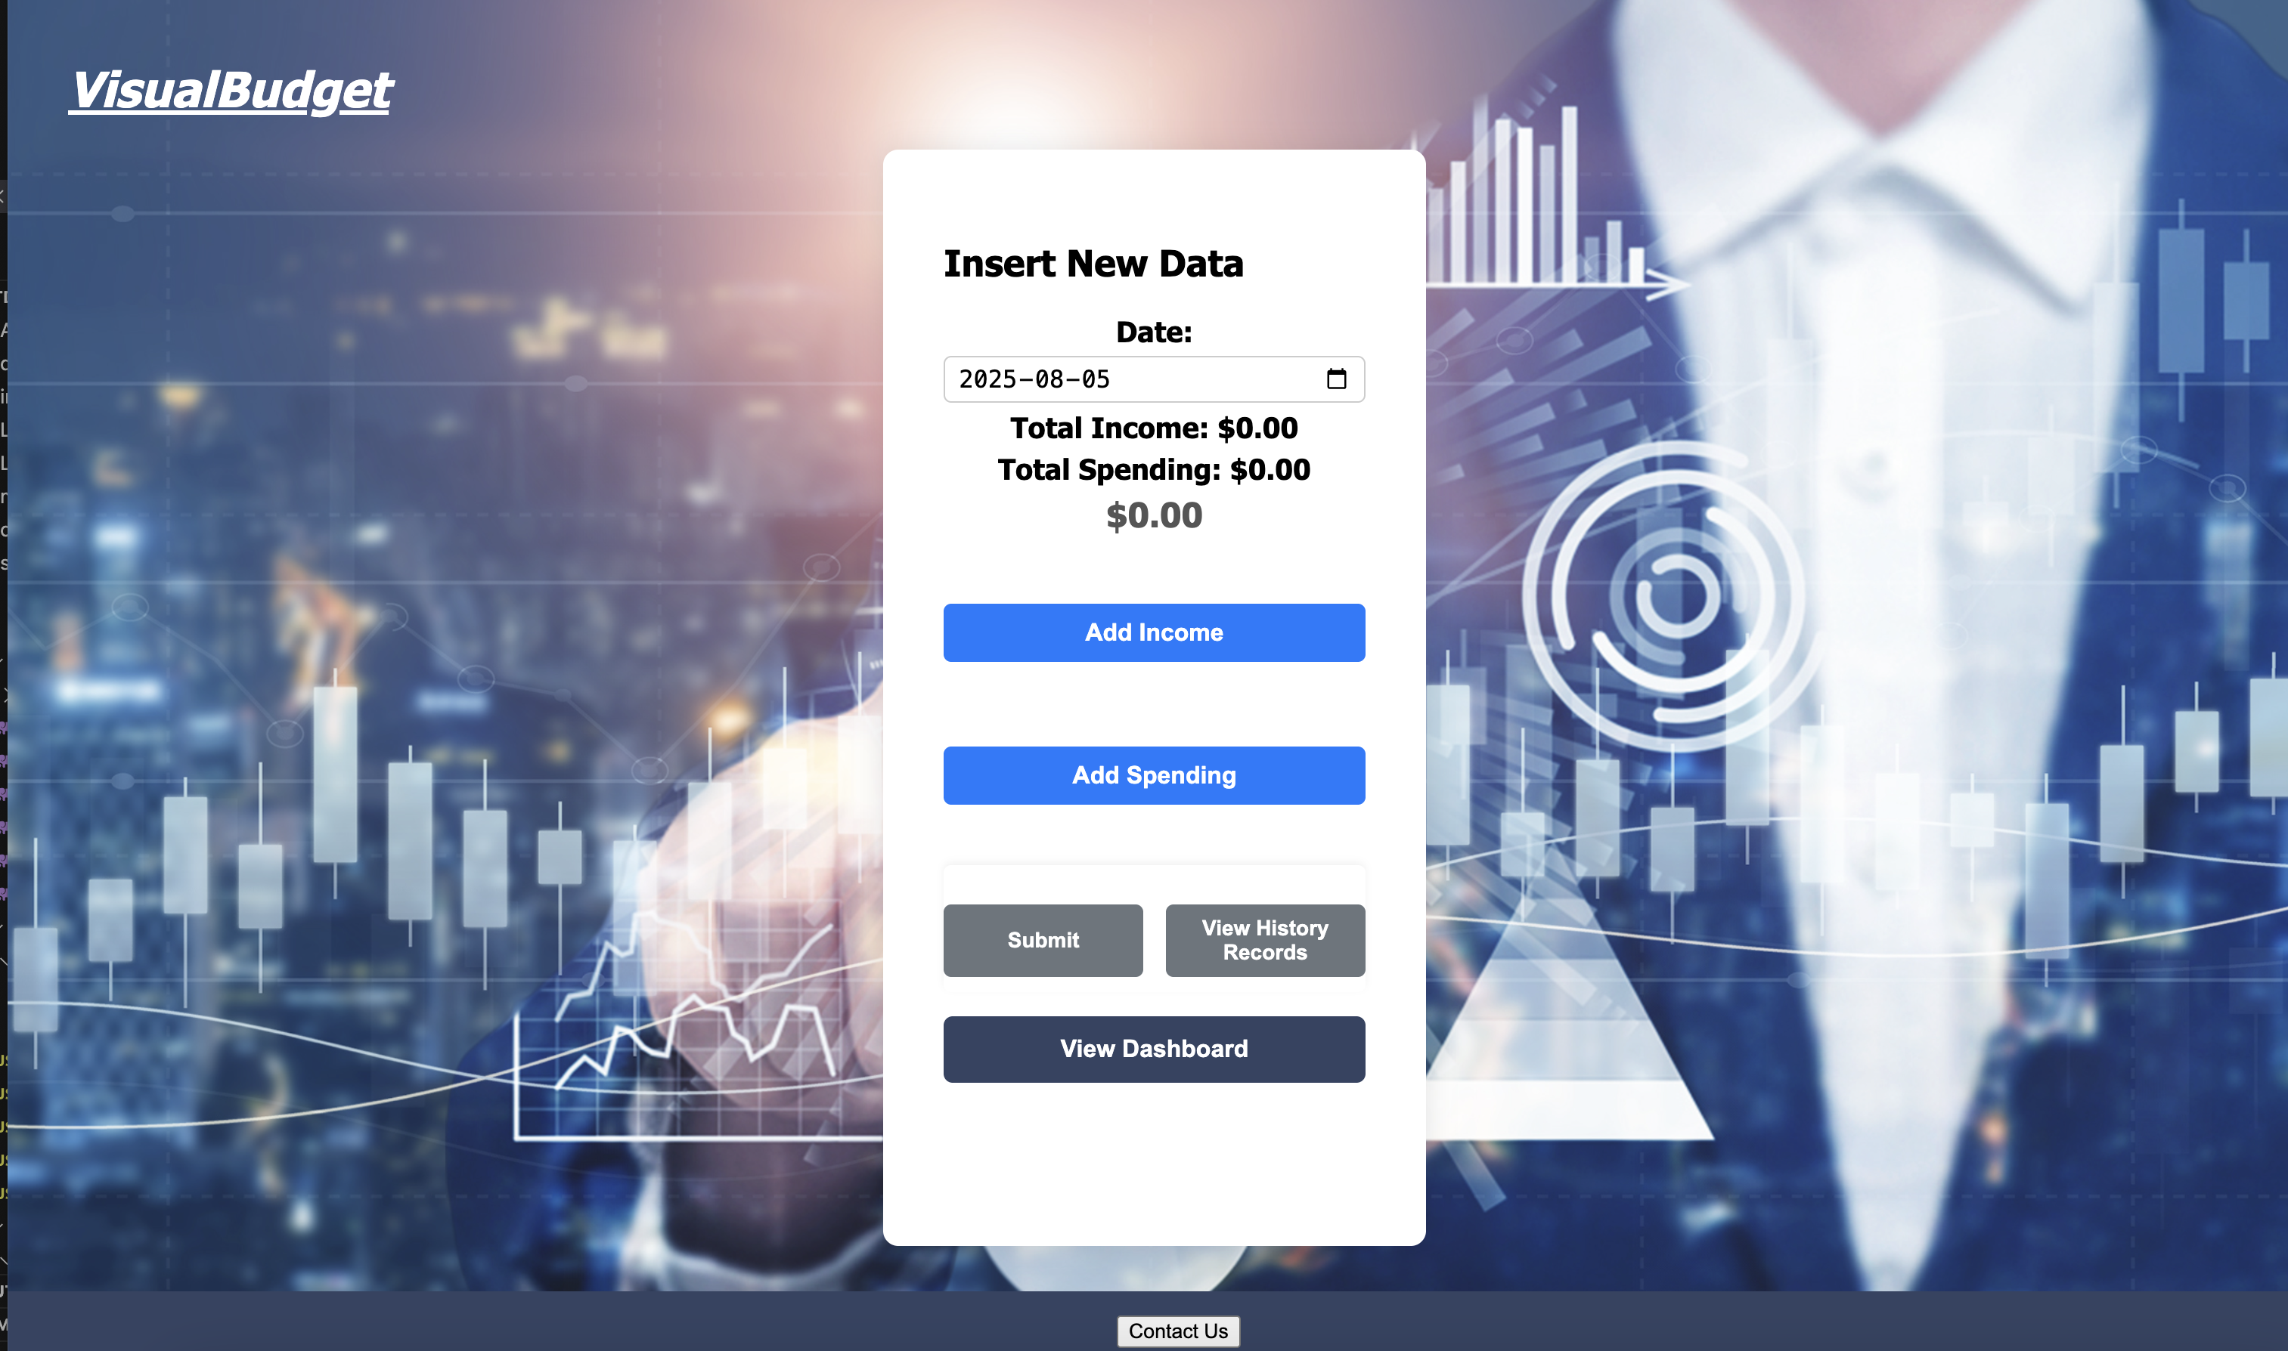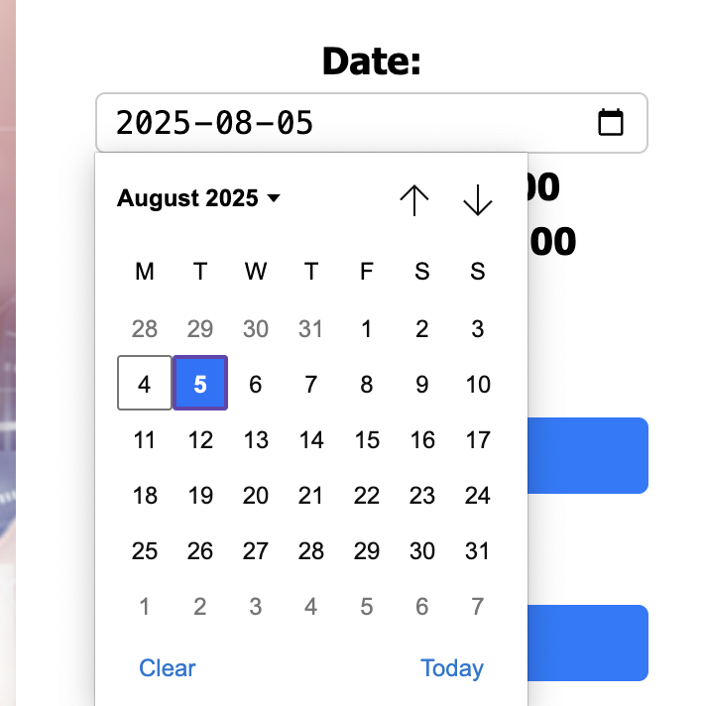

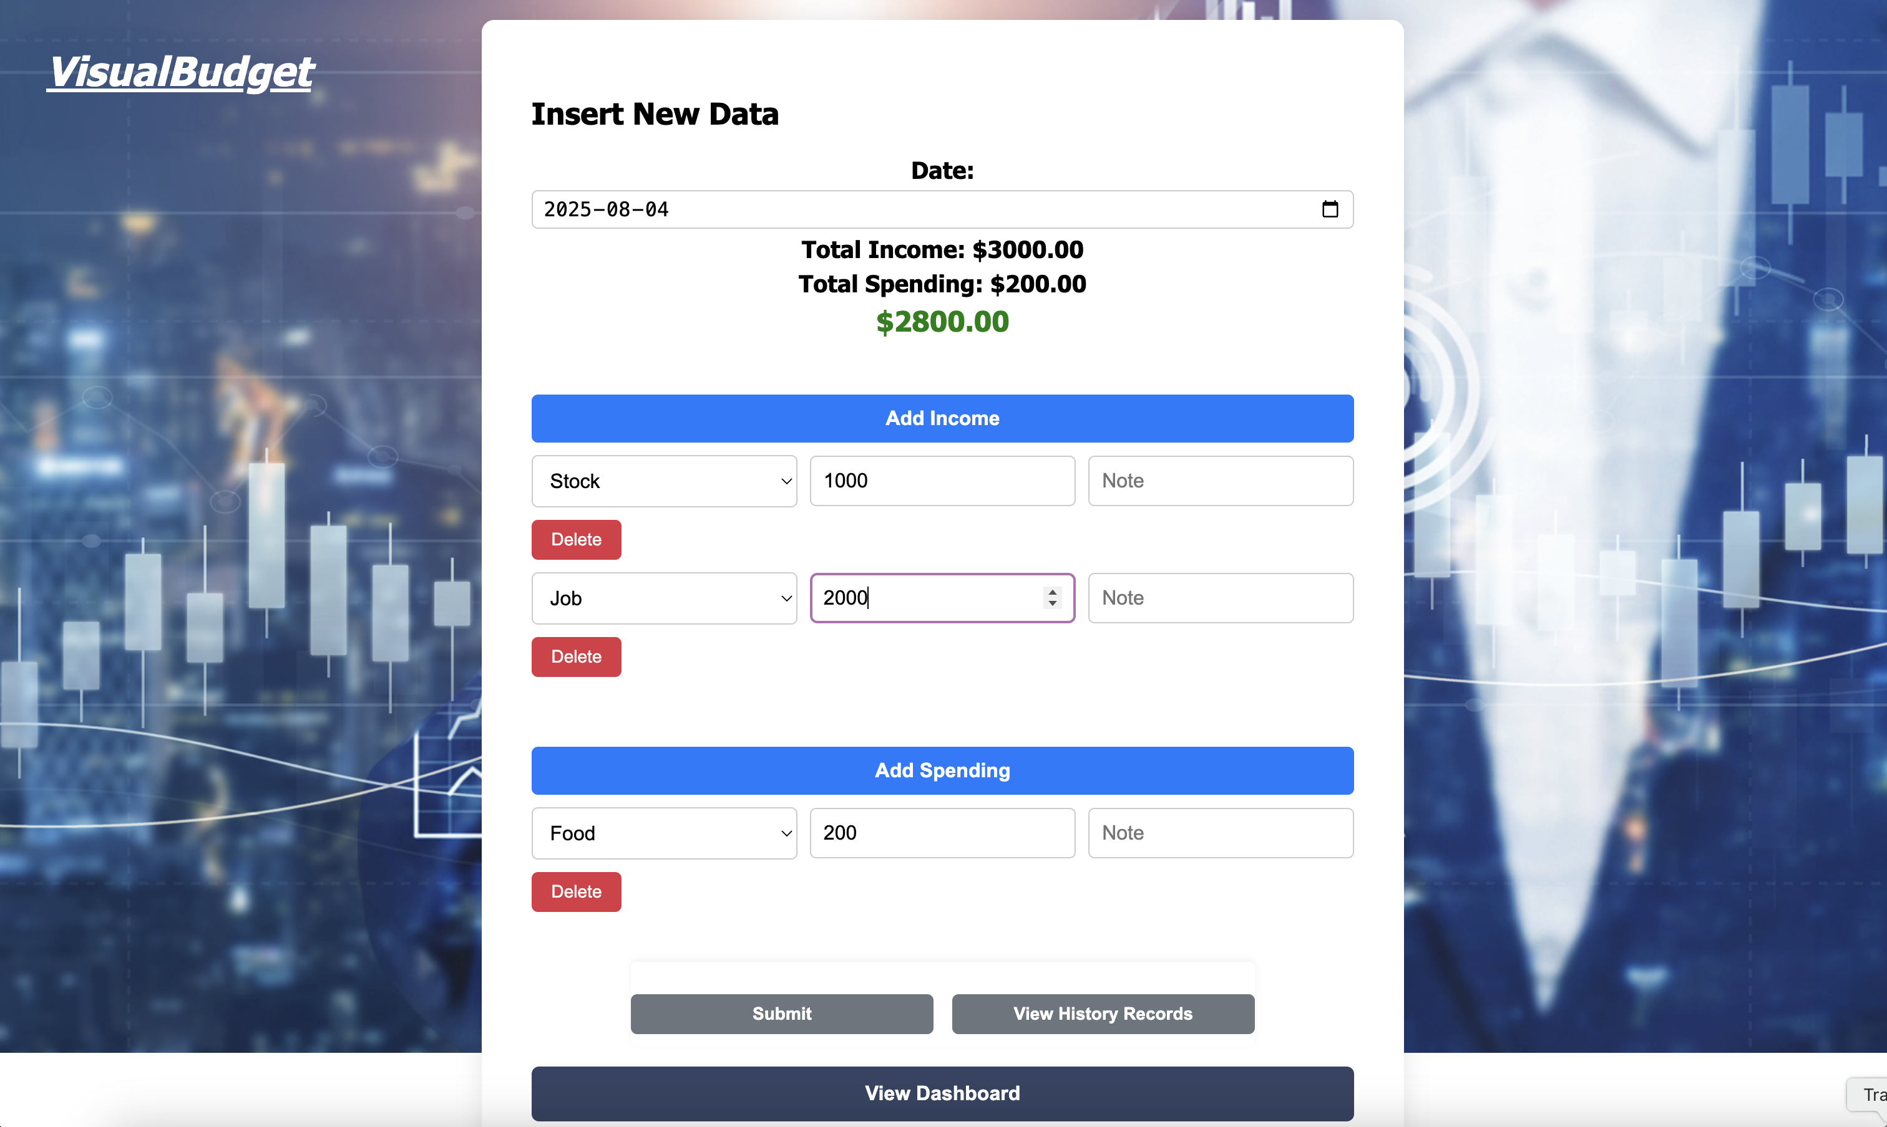

* **Validation:**
  + If the user attempts to leave the page without submitting, a warning is shown.
  + If required fields (**Category**, **Amount**) are blank, a warning is displayed.

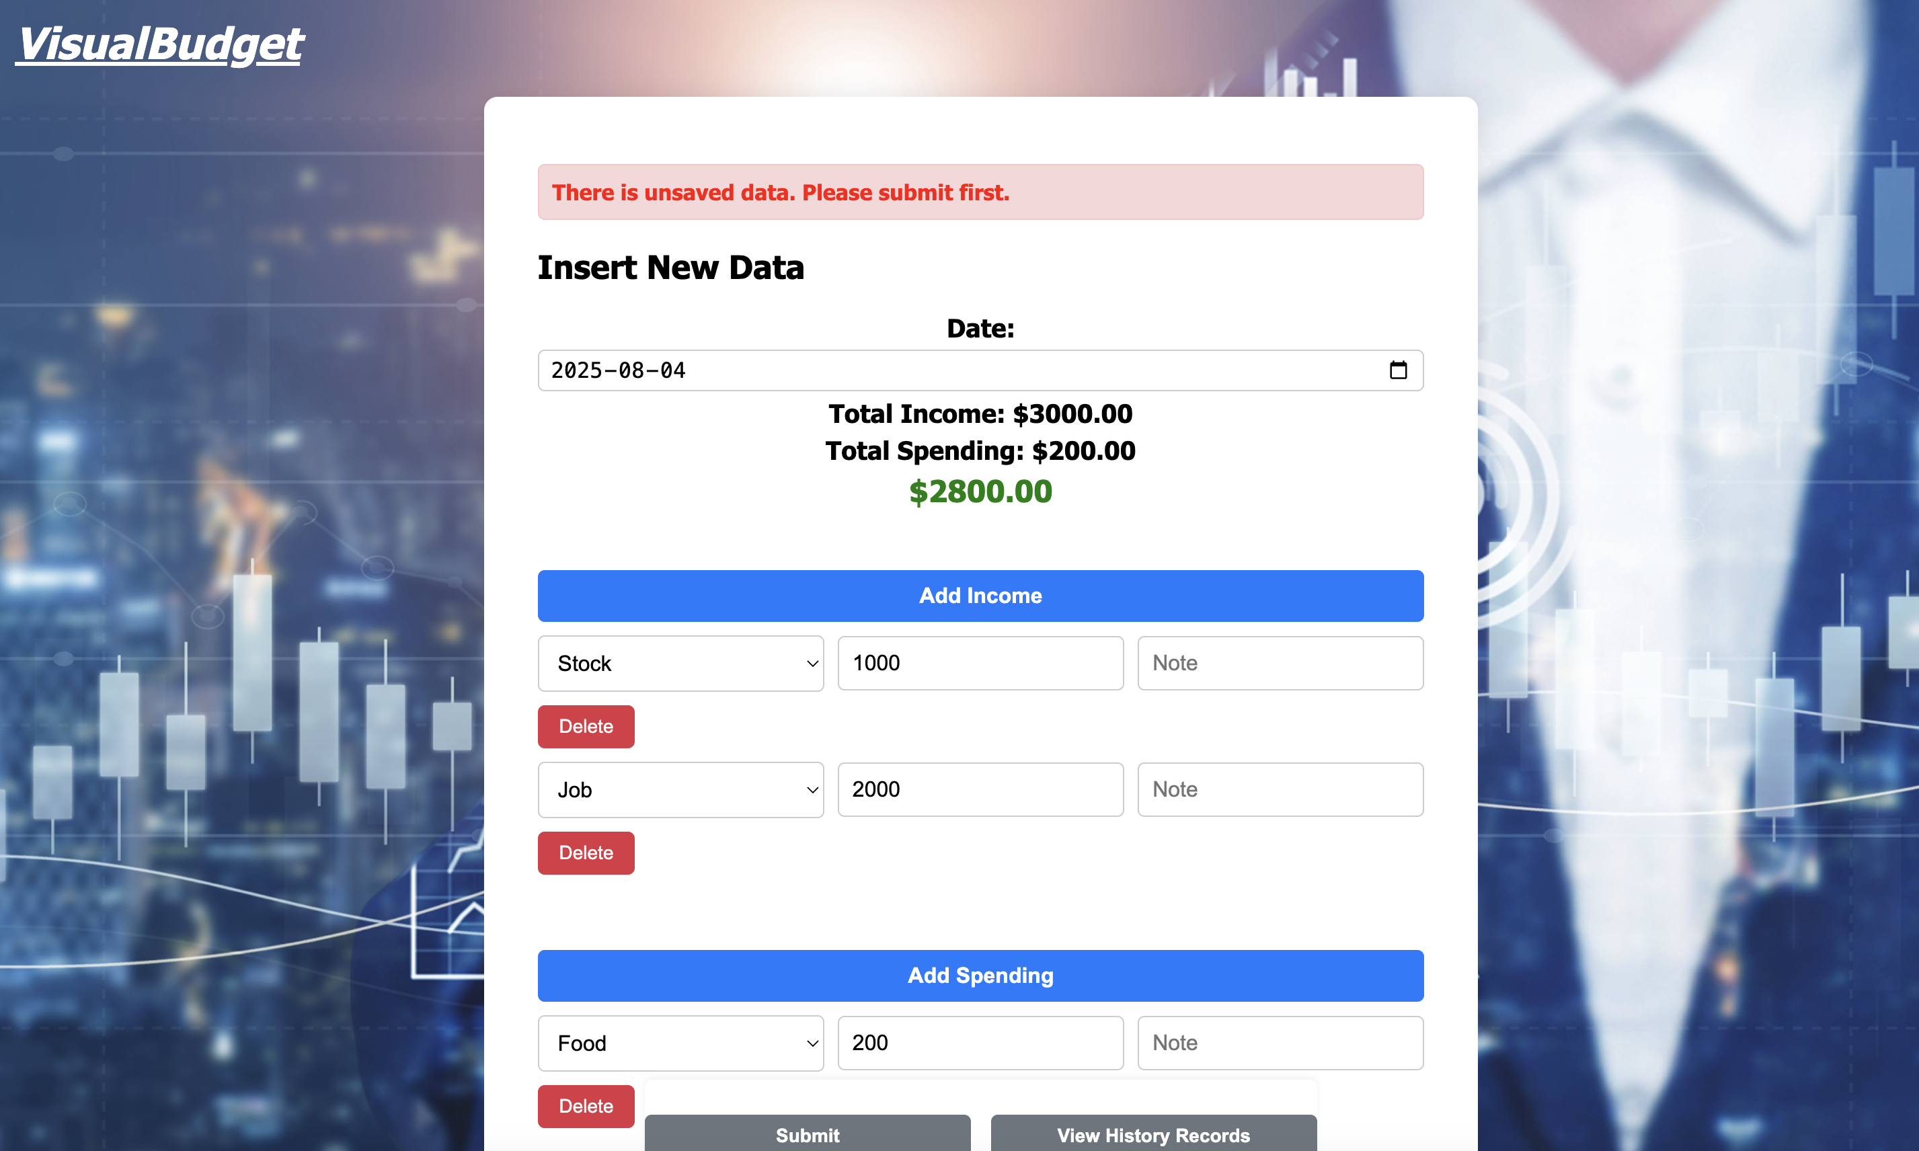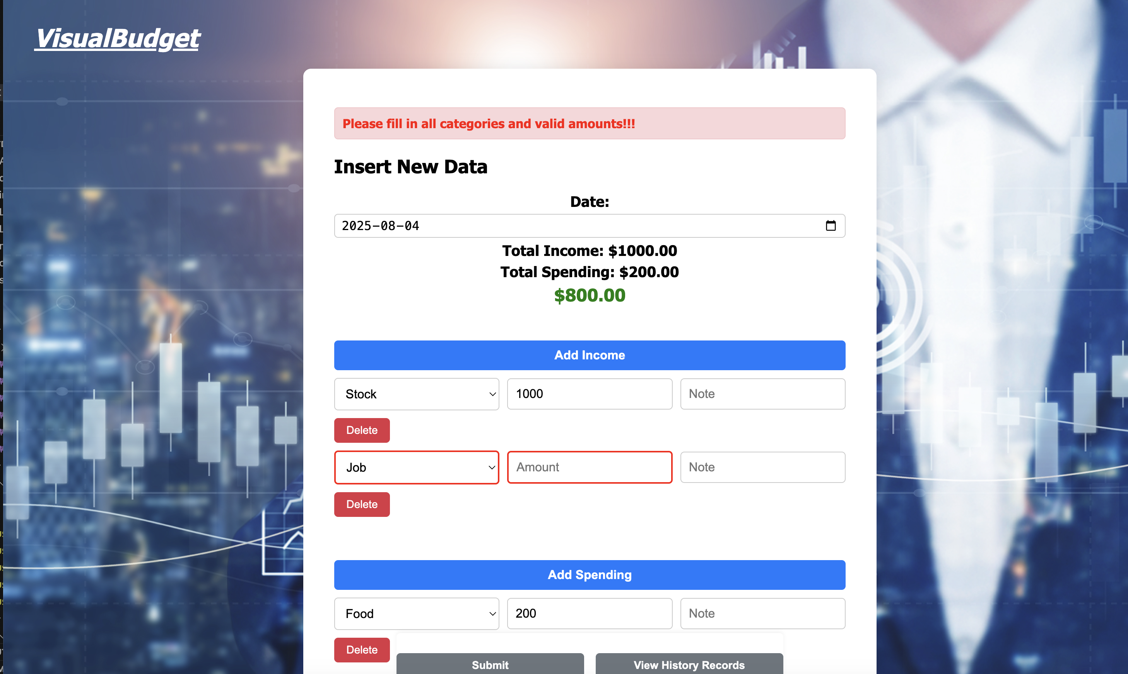

* + After successful submission, a confirmation message is displayed.

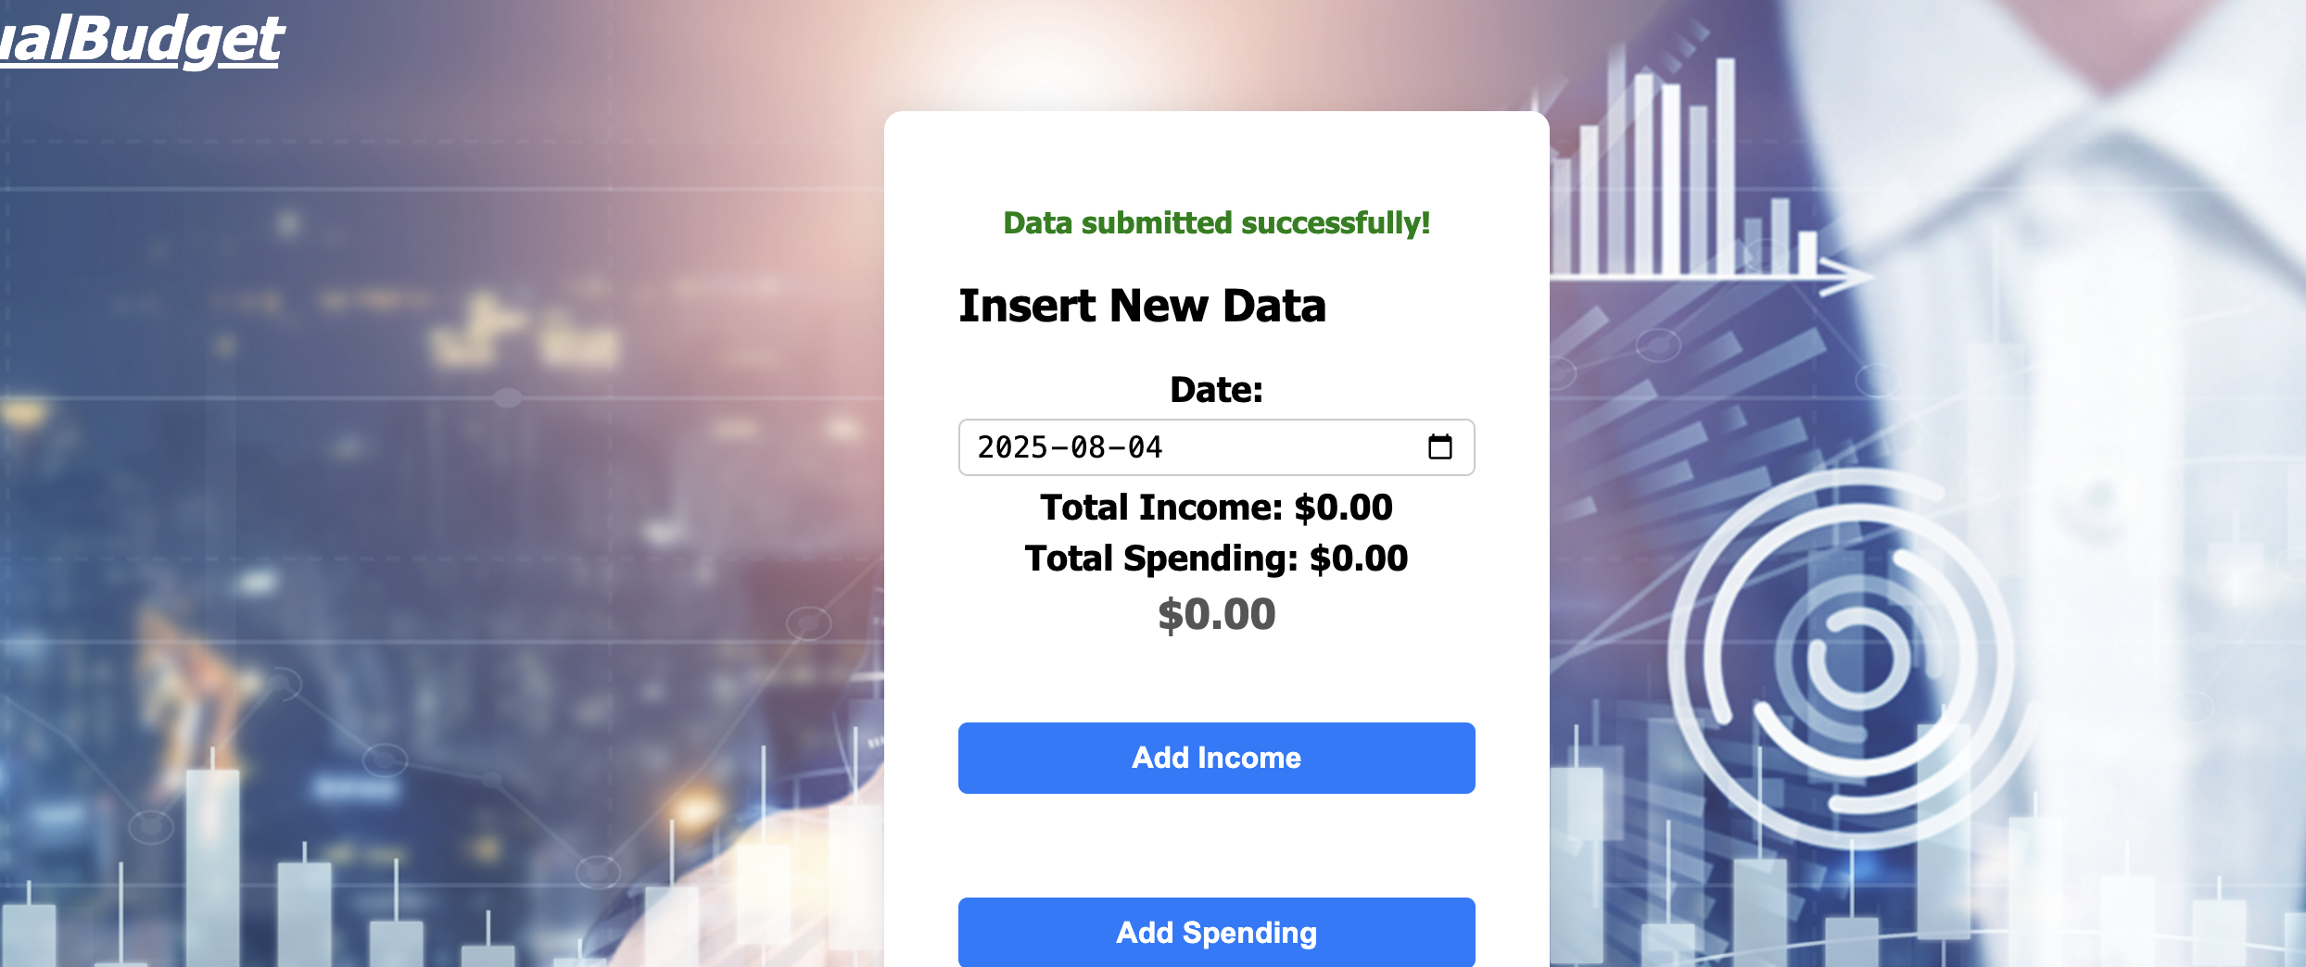

* Navigation options:
  + **View History Records** – to review and edit past entries.
  + **View Dashboard** – to visualize the data.

**(5) History Page**

* Accessible via **“View History Records”** from the Data Input page.
* Allows the user to:
  + Search transactions using keywords.
  + Filter records by category.
  + Edit or delete existing records.

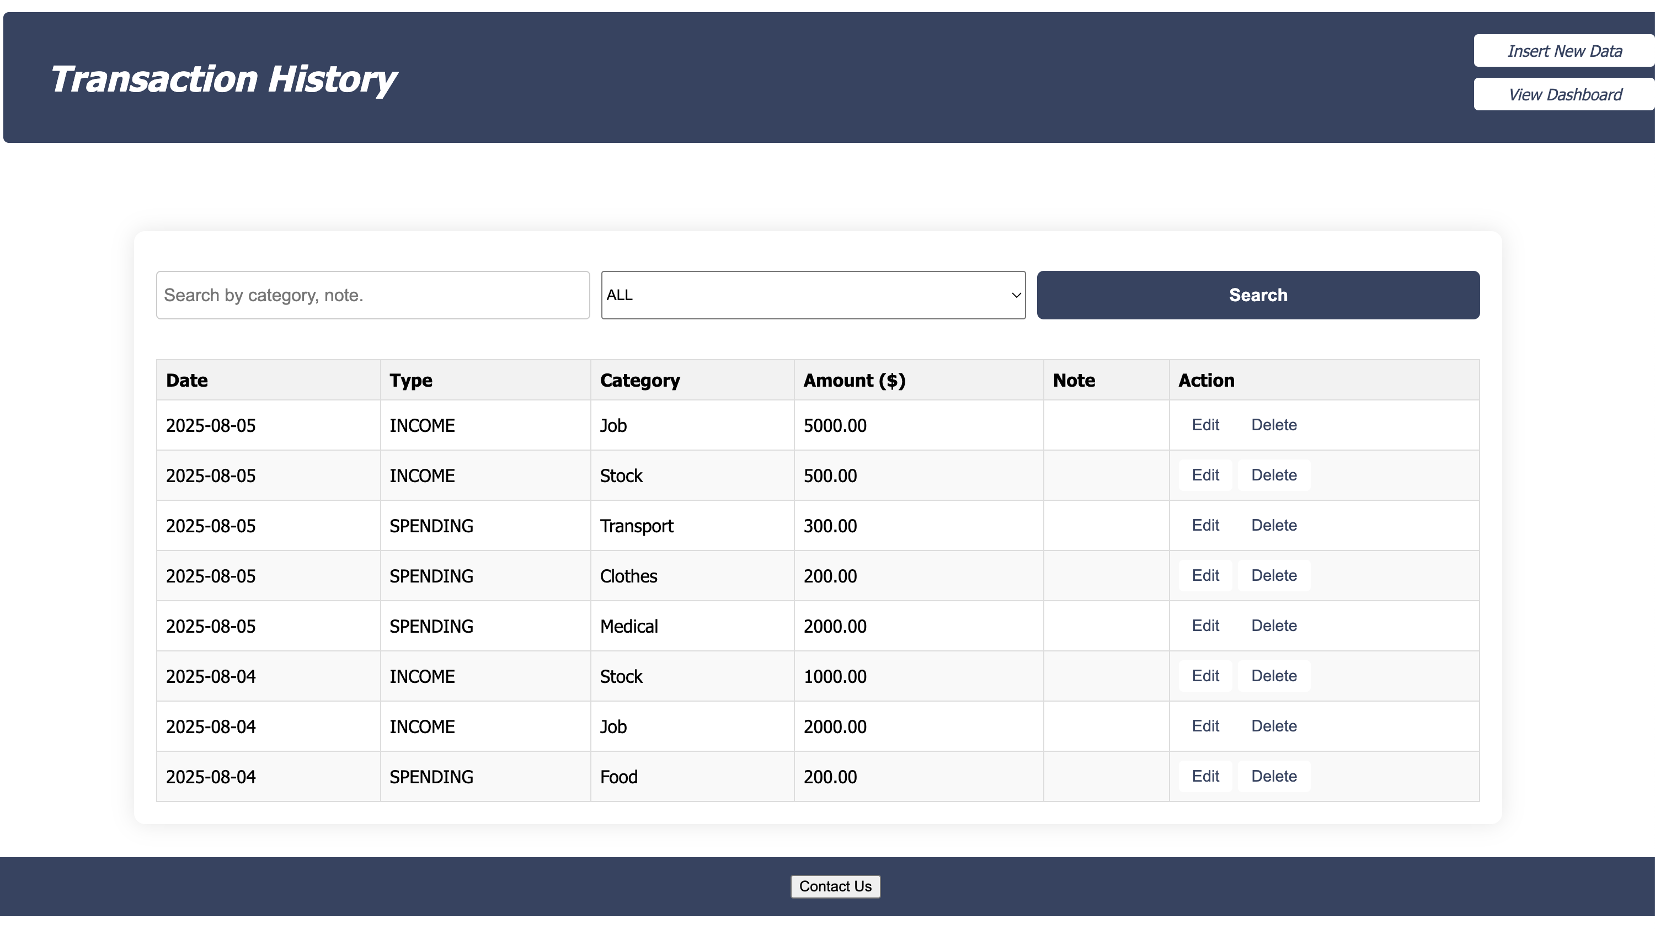

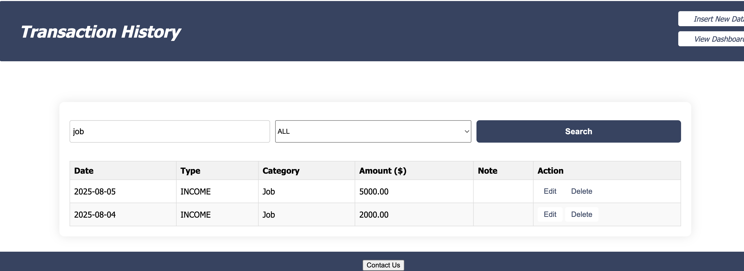

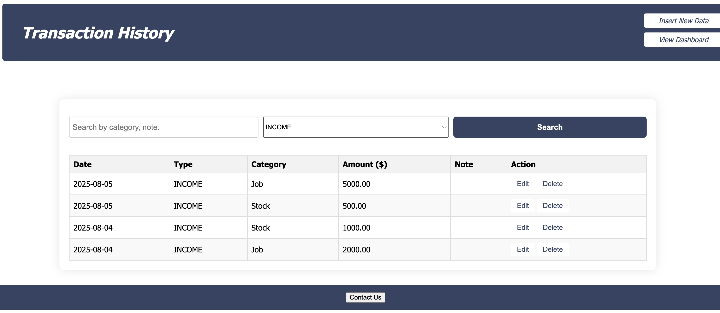

* Navigation options:
  + **Insert New Data** – returns to the Data Input page.
  + **View Dashboard** – navigates to the Dashboard.

**(6) Dashboard Page**

* Displays financial data visually using:
  + **Pie charts** – showing spending and income distribution by category.
  + **Bar charts** – showing amounts over time.
* Users can select a time range to filter displayed data.

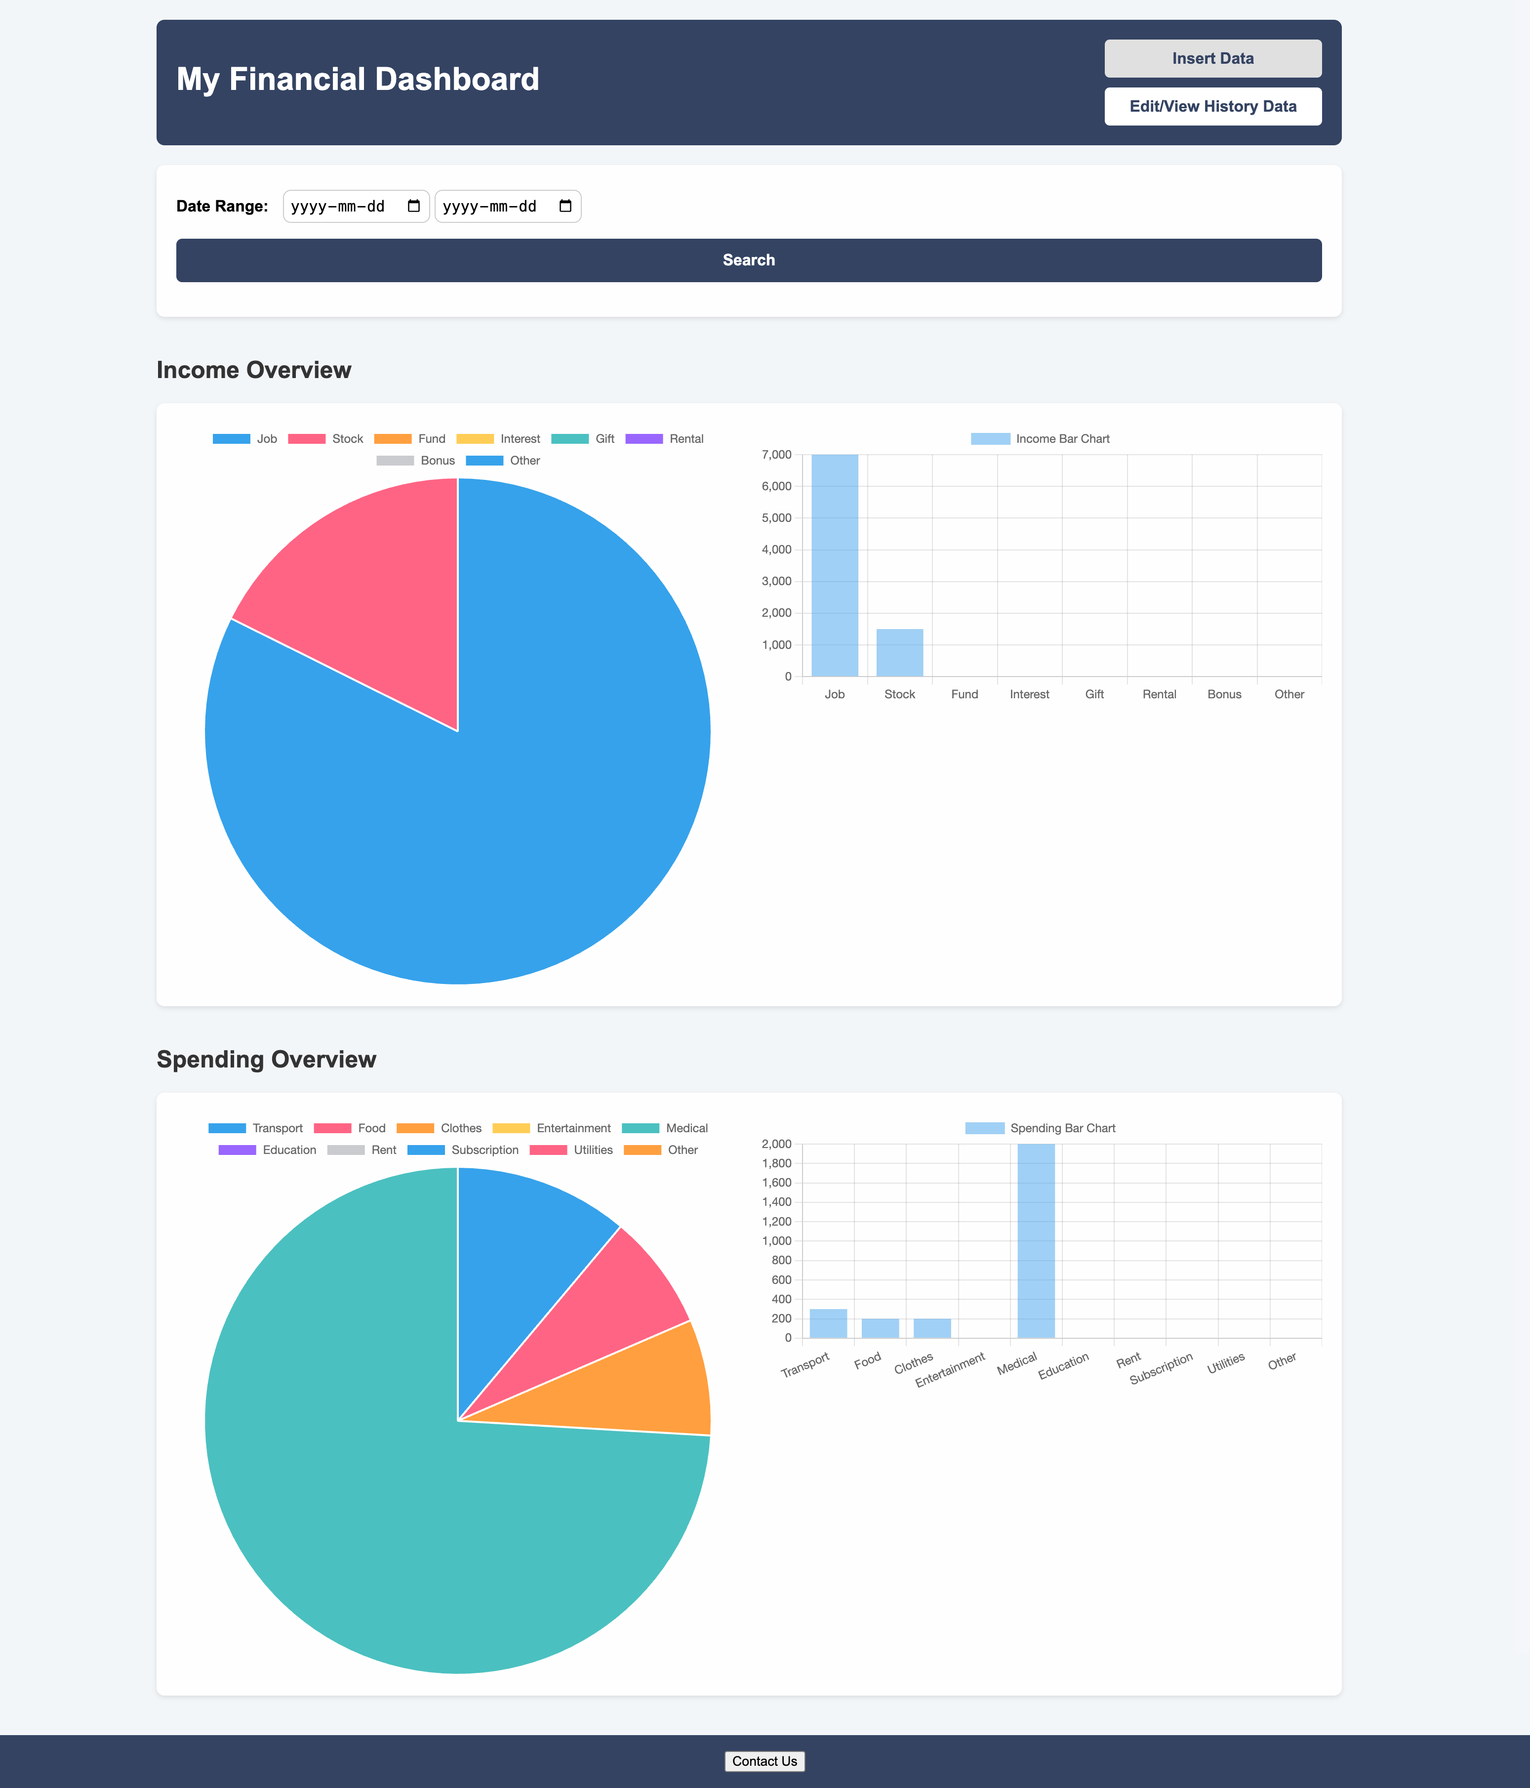

**3. Data flow**

